**Injection Molds 101: Cold runner vs. hot runner Molds**

## 1. Introduction

Over the past few decades, the injection molding process has evolved significantly more than almost any other manufacturing process and has influenced the development of numerous products. Injection molding consists of softening the material in a heated cylinder, injecting it into the mold cavity under pressure, and then hardening it by cooling. Injection molding technologies are mainly divided into two main categories: hot runner and cold runner mold systems. A hot runner mold is a system that heats the molds and runner channels to keep material in a molten state for the duration of the injection process until the mold cavity is filled, leaving no plastic inside the runners. In a cold runner system, the runners and the molds are not heated. The plastic fills the runners and mold cavities. The material then cools inside these cavities, which keeps the runners and parts connected until they are ejected and separated. Each of these systems has distinct advantages over the other. So, the choice between these two mold systems depends upon various factors like cost-effectiveness, material usage, material wastage, cycle times, and part quality.

**2. Understanding cold runner molds**

Cold runner molds are the common type of injection molds that are being used for decades. It consists of two or three plates held within the base plate. In cold runner molds, molten plastic is conveyed into the mold cavity through unheated channels, known as runners. The runner is basically a delivery system that distributes the plastics to each cavity within the mold. The cold runner mold system is divided into two types: (i) two-plate system and (ii) three-plate system. The two-plate cold runner system consists of two plates with the stationary mold containing the sprue, runners, gate, and cavities. The runner is attached to the final product and should be cut off. In three-plate system, there is no need to cut the runner from the injection molded part, and the mold has a self-ejection system for part removal.

The working principle involves injecting molten plastic into the mold cavity through an unheated channel. First, the plastic is melted and then injected into the mold via a sprue connected to the runners. These runners guide the molten plastic to the mold cavities, ensuring uniform distribution of the material through gates. Then, the final part is formed, after the plastic cools and solidifies. In two-plate mold system, the runners and the part are not separated, requiring an ejection system to detach the molded component from the core half of the mold. In contrast, three-plate molds have a separate cavity plate that contains the runners. In three-plate system, there is no need for the separation of runners and the part, and doesn’t require an ejection system.

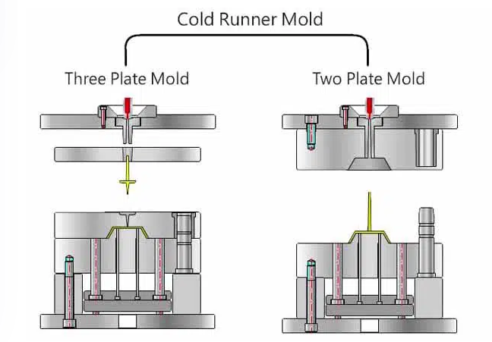

Figure 1 Cold runner mold and its types (source: <https://www.myplasticmold.com/how-to-chose-correct-injection-mould.html>)

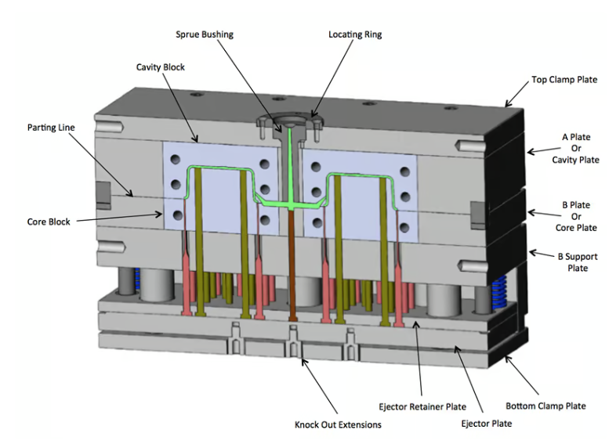

Figure 2 Cold runner mold system (source: https://www.plastopialtd.com/cold-runner/)

### Advantages

1. **Lower initial cost:**

The absence of a heated manifold system in cold runner molds makes it lower in initial cost compared to a hot runner system. Cold runner molds have a simpler design which makes it a budget-friendly option. Also, maintenance and repair costs are very low compared to the hot runner molds.

1. **Flexibility in material use:**

As the runners are unheated, there is no risk of heat degradation or pre-mature melting for heat-sensitive plastics. Whether its commodity plastics like polyethylene, or engineering plastics like ABS or nylon, cold runner molds are feasible for these all materials in manufacturing.

### Disadvantages

1. **Material waste:**

In each molding cycle, the unheated runners that are filled with molten plastic solidify along with the molded parts. When the part has to be ejected after each cycle, the solidified plastic at runners becomes unusable. This creates a major drawback when manufacturing on large scales. This results in a huge amount of material waste.

1. **Longer cycle times:**

Cold runner mold has longer cycle times compared to hot runner mold. In unheated runners, the cooling and solidification phase of the plastic takes a considerable amount of time, which slows down the overall manufacturing.

## 3. Understanding Hot Runner Molds

Nowadays, hot runner molds are the cutting-edge technology for injection molding. It consists of two plates that are heated through a manifold system. This manifold ensures that the plastic remains in a molten state until it flows into the cavity of the mold. Hot runner molds are categorized into two types, and they are insulated hot runners and heated hot runners. Insulated hot runner molds have extremely thick runners in the mold plate, which causes part of the molten plastic to cool down and insulate the system. This insulation results in reduced heat loss and allows the mold system to maintain an open plastic flow. Heated hot runner is further divided into two types: externally heated and internally heated molds. In externally heated molds, rods, coils, or pipes are used to heat the plates from outside of the mold. This type of mold is suitable for materials that are sensitive to thermal variations like polymers. On the other hand, internally heated mold has a heating component inside of the mold which leads to a drop in injection pressure. Also, it offers better flow due to the heated runner and gate tip control.

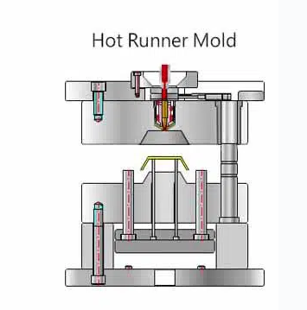

Figure 3 cold runner mold (source: <https://www.myplasticmold.com/how-to-chose-correct-injection-mould.html>)

The working principle of hot runner molds revolves around maintaining the plastic in a molten state until it flows into the mold cavity. The manifold system that contains a heating component, manifold, and nozzle, ensures that the plastic remains at the required temperature. Hot runner molds eliminate the need for runners which reduces material wastage and leads to more efficient production processes. Hot runner molds are a versatile and efficient solution for injection molding needs, offering consistent quality, faster cycle times, and potential cost savings in the long run.

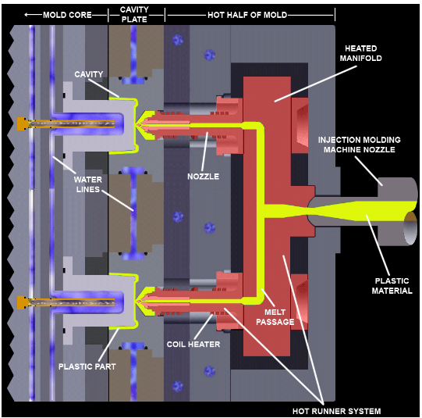

Figure 4 hot runner mold system (source: <https://www.echosupply.com/blog/injection-molding-basics-hot-runner-systems/>)

### Advantages

1. **No material waste:**

Hot runner mold eliminates the need for the runners in their molding process and this results incomplete elimination of wastage due to solidified runners.

1. **Faster cycle times:**

They offer faster cycle times than cold runner molds. The molten plastic is continuously supplied to the mold cavities, allowing for quicker filling and cooling which saves lots of time. This advantage makes them a suitable choice for high-volume production businesses.

### Disadvantages

1. **Higher initial cost:**

One of the major drawbacks of the hot runner mold system is their higher initial cost as it requires manifold, heating components, and nozzles, to maintain the plastic in a molten state throughout the process. The additional components and technology involved in hot runner systems contribute to increased upfront investment.

1. **Limited in material use:**

Some plastics are sensitive to high temperatures, and longer exposure to heat in hot runner molds can lead to material degradation or undesirable changes in the plastic properties. Heat-sensitive polymers like thermally unstable resins might not be suitable for use in hot runner molds.

## 4. Comparison between Cold Runner Molds and Hot Runner Molds

### **Cost effectiveness**

### Hot runner systems require a higher initial investment and maintenance cost due to their complexity, including manifold systems, heating components, and nozzles. The reduced cycle time enhances efficiency and output rates, offsetting the initial investment over time. In contrast, cold runner mold systems have a lower tooling cost which makes them more economical for small-scale production and prototyping. The absence of a manifold system simplifies the design and lowers expenses. That’s why the cold runner system gets a cutting edge over the hot runner system on the basis of cost-effectiveness. Nonetheless, cold runner molds result in significant material wastage due to solidified plastics at runners and gates, making them less cost-effective for long-term and large-scale production.

### **Production speed**

### Hot runner molds system is faster in production speed compared to cold runner molds. The streamlined design of hot runner mold systems eliminates the runner removal process which enables faster filling and cooling of parts. On the other hand, cold runner molds consist of additional steps of separating, grinding, and recycling runners which leads to slower production. While hot runner systems may require a higher initial investment, their ability to produce more parts per unit of time makes them a preferred choice for manufacturers seeking increased production efficiency and output rates.

### **Materials use**

### Cold runner molds are superior to hot runner molds in terms of material varieties that can be used in the molding process. Some thermoplastic materials like thermal-sensitive resin or polymers are particularly sensitive to temperature variation. The heat in a hot mold system creates negative impacts on the mechanical properties of these materials. Cold runners don’t have any heating component which makes them more compatible with a wide range of thermoplastic materials.

### **Quality of final product**

### Hot runner molds offer superior final product quality than cold runner molds. The hot runner system delivers an excellent filling profile with consistent injection pressure to manufacture well-formed and defect-free parts. In contrast, cold runner molds have to go through injection pressure drop due to heat transfer to the mold plates during plastic flow. This leads to shrinkage and the formation of sink marks and under-filled parts

Table 1. Hot Runner vs. Cold Runner Comparison

|  |  |  |
| --- | --- | --- |
| **Attributes** | **Hot Runner** | **Cold Runner** |
| Allows quick changes in design or color | No | Yes |
| The high degree of tolerance | Yes | No |
| Works with a variety of thermoplastics | No | Yes |
| High maintenance cost | Yes | No |
| Produces large volumes of parts | Yes | No |
| Uses unheated runner | No | Yes |
| Molten thermoplastic or polymer is used | Yes | Yes |

**5. Case StudiesTop of Form**

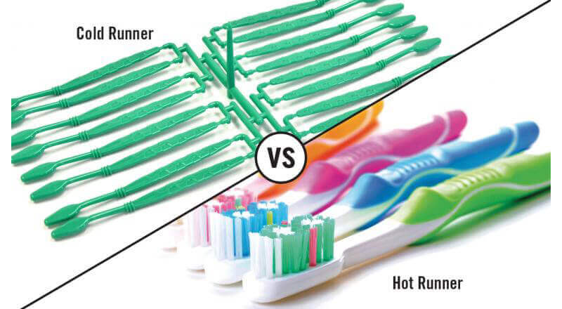

Source: <https://www.hitcontrols.com/hot-runner-v-s-cold-runner/>

As you know, both cold runner molds and hot runner molds have their strengths and weaknesses. Therefore, the choice between the two depends on the part complexity, production volume, material characteristics, and cost considerations. Let's look at some examples of successful use for both types:

Successful Use of Cold Runner Molds in Industry

1. Food Packaging industry to produce plastic food containers, trays, disposable cutlery, utensils bottle caps, and packaging components in an economical way.
2. Building and Construction to manufacture plastic parts such as pipes, fittings, and construction elements like brackets and fasteners.
3. Toys industry to produce plastic toys, playground equipment, and recreational items.
4. Produces household goods such as storage containers, household tools, and cleaning equipment.
5. Medical industry to produce certain medical-grade plastics as well as specialized engineering resins.
6. Automotive industry to manufacture interior components like dashboards, door panels, seat trims, automotive bumpers, large containers, and appliance components.

Successful Use of Hot Runner Molds in Industry

The ability to control the molten plastic flow, minimize gate marks, and reduce material waste makes hot runner molds a popular choice in a wide range of industries, especially when producing high-value, intricate, and complex parts.

1. Produce electrical components like closures, connectors, and small precision components due to the ability of hot runner systems to ensure tight tolerances, resulting in optimal electrical performance.
2. Medical Devices and Instruments including syringes, IV components, and surgical instruments where hot runners ensure the production of sterile, defect-free parts.
3. Cosmetic industry to produce packaging components such as lipstick cases, compact cases, and mascara containers.
4. Automotive lighting components, including headlamp housings, taillight lenses, and signal indicators.
5. Household appliances such as microwave parts, washing machine components, and vacuum cleaner parts.
6. High-End consumer products like smart phones, high-quality audio equipment, and luxury goods.

**6. How to Choose Between Cold Runner and Hot Runner Molds**

There is no perfect answer as the choice depends on several factors like production needs, material and cost. Larger and more complex parts benefit from hot runner systems due to reduced material waste, cycle time, and quality issues. Whereas, smaller parts benefit from cold runner systems as they require less material and energy. The injection molding industry generally makes the decision to use a hot runner without considering a cold runner’s possible cost and quality benefits. It is true that hot runners require less material, less cost; however, they can create more scrap because of downtime and leaks. Choosing between cold runner and hot runner molds requires careful consideration of various factors related to production needs, material type, and cost considerations.

1. Assessing Production Needs:

|  |  |  |  |
| --- | --- | --- | --- |
| **SN** | **Needs** | **Hot runner molds** | **Cold runner molds** |
|  | Part complexity | Hot runner molds for intricate, complex parts with multiple gates. | Cold runner molds for simpler designs with a single gate. |
|  | Production volume | For high-volume production, hot runner is cost-effective in the long run due to reduced material waste. | For low-volume production, cold runner molds are more economical. |
|  | Cycle time | Hot runner molds offer faster injection and cooling cycles that helps in meeting tight production schedules. | Cold runner molds reduce downtime during maintenance, resulting in increased productivity and reduced production interruptions. |

1. Considering Material Type:
   * Material Sensitivity

Materials that sensitive to heat and shear prefer cold runner molds in order to minimize the chances of material degradation. Hot runner is fitting for materials that can withstand the higher temperatures.

* + Material Flow and Viscosity

Hot runner molds suitable for materials with higher viscosity whereas cold runner molds can still work with materials with adequate flow properties and lower viscosity.

* + Material Compatibility with Mold Components

For materials with high abrasive qualities, hot runner molds ensure longer mold lifespan and consistent performance. For materials that cause less wear on the mold's components, cold runner molds are appropriate.Top of Form

1. Evaluating Cost Factors:
   * Initial Investment

Cold runner molds are less expensive to manufacture and purchase, while hot runner molds have a higher initial cost due to the complexity of the system.

* + Production Costs

Hot runner molds can lead to lower production costs in high-volume scenarios due to reduced material wastage and faster cycles.

* + Tooling Maintenance

Cold runner molds are generally simpler and easier to maintain, while hot runner molds might require more specialized maintenance.

**7. Conclusion**

The correct choice between cold runner and hot runner molds is vital in determining production efficiency and part quality. Cold runner molds being a cost-effective solution for low-volume production of simpler part designs and hot runner molds excelling in high-volume production with faster cycle times and minimal material wastage, it is essential to assess your needs and then make a selection between these two. All-in-all, the key to getting the finest results and satisfying the requirements of various sectors and applications is to choose molds carefully.